Task 1: Python File Handling and Automation
Name: Muyassar Ochilova
Internship: Python Developer Internship
Objective: The purpose of this task is to demonstrate Python file handling operations, automation, and exception handling.
Requirements Completed:
1. Read and write a text file
2. Rename the file
3. Move the file to another folder
4. Delete the file
5. Use try-except for error handling
import os
import shutil
try:
# 1. Create and write to a text file
with open("student.txt", "w") as file:
file.write("Name: Muyassar Ochilova\n")
file.write("Internship: Alfido Tech\n")
file.write("Language: Python\n")
print("File created successfully.")
# 2. Read the file
with open("student.txt", "r") as file:
print("\nReading file:")
print(file.read())
# 3. Rename the file
os.rename("student.txt", "information.txt")
print("File renamed successfully.")
# 4. Create a folder
if not os.path.exists("Backup"):
os.mkdir("Backup")
# 5. Move the file
shutil.move("information.txt", "Backup/information.txt")
print("File moved successfully.")
# 6. Delete the file
os.remove("Backup/information.txt")
print("File deleted successfully.")
except FileNotFoundError:
print("File not found!")
except Exception as e:
print("An error occurred:", e)
Code Explanation - This Python program creates a text file and writes information into it. Then it reads the file contents, renames the file, moves it to a Backup folder, and finally deletes it. Exception handling is implemented using try-except blocks to prevent the program from crashing if an error occurs.
Output. The program executed successfully and displayed the following messages:
File renamed successfully.
File moved successfully.
File deleted successfully.
Process finished with exit code 0
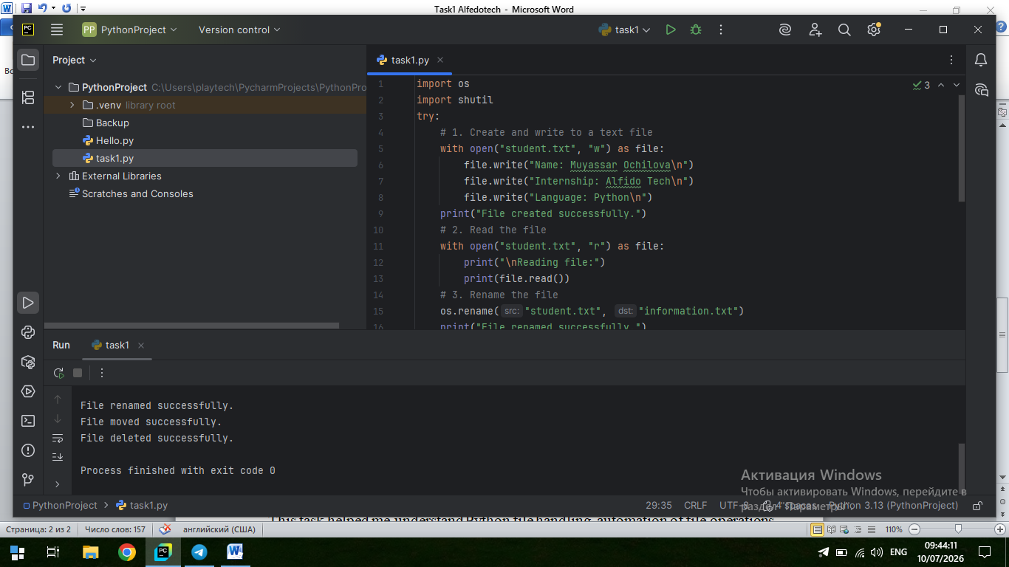

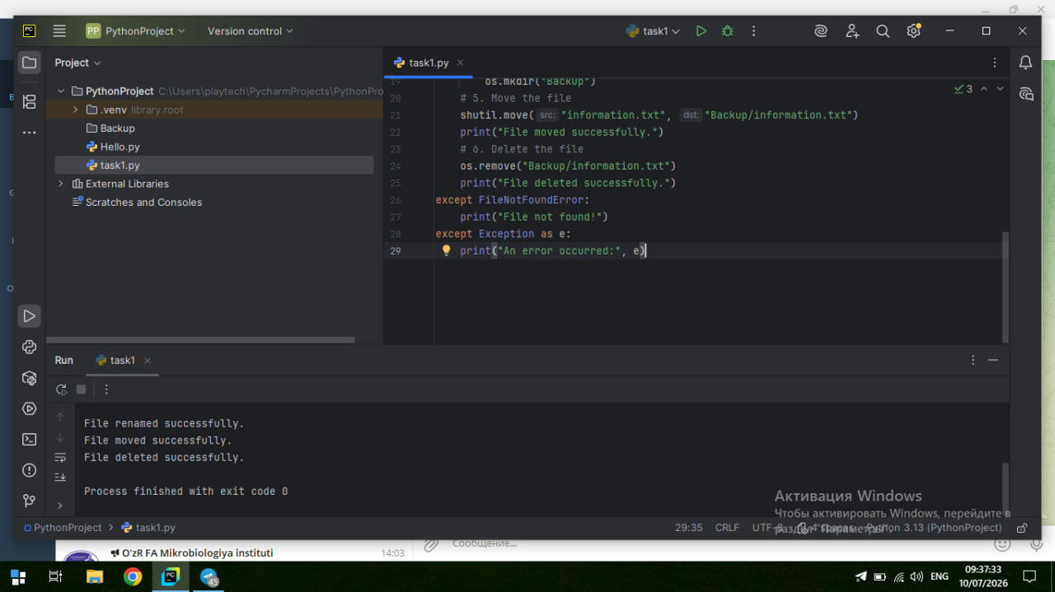
Conclusion. This task improved my understanding of Python file handling, file automation, and exception handling. I learned how to create, read, rename, move, and deletes files using Python while handling possible errors with try-except statements.

